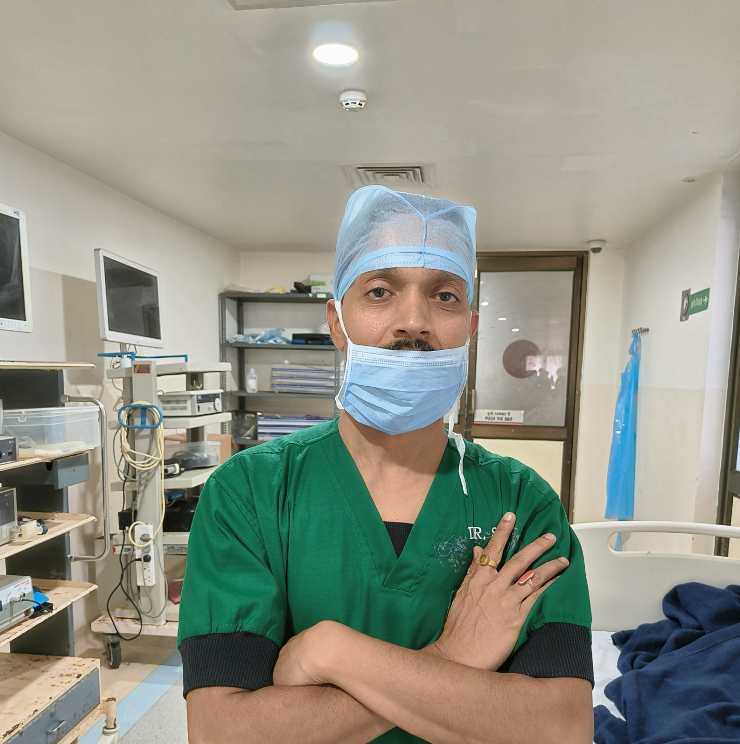DR. Rambabu Garg
(LAPARASCOPIC SURGEON & UROLOGIST)
MBBS MS FLAGES

